**November Monthly Report**

Zihan Qiao (Weibo)

**The workflow of Weibo in November**

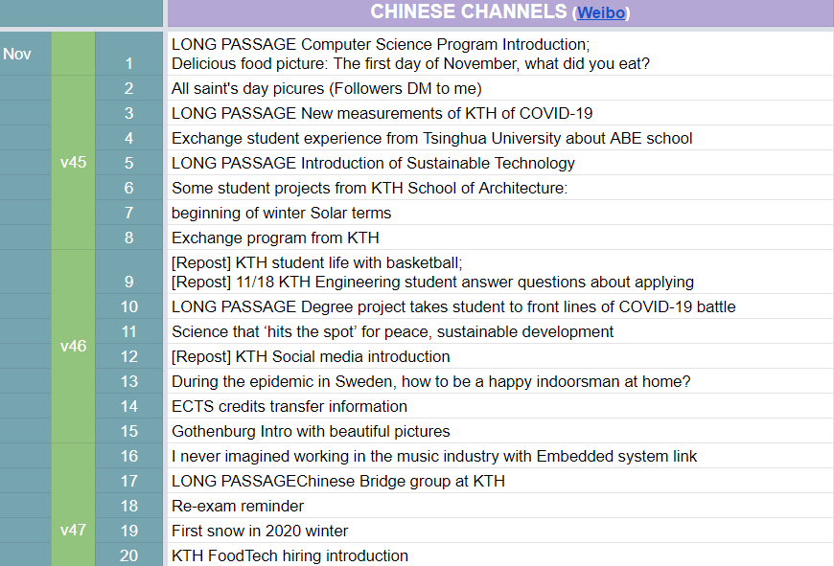

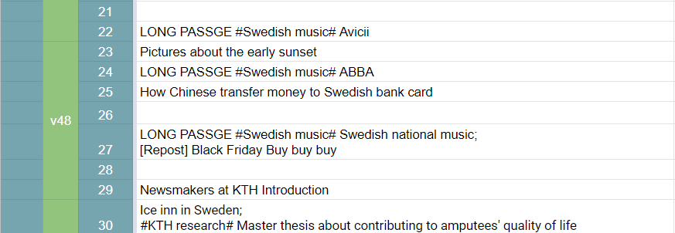

Figure 1 Content Sheet for November

**Statistics**

The number of long passages: 8;

Missed days: 3;

On 2020/11/1, there are 21762 followers.

On 2020/12/1, there are 23643 followers.

There are 1881 new followers in one month.

**Shining point:**

1. The application FAQ continuous updating and pinned to the top;
2. Write three passages about Swedish songs. Including Avicci, ABBA, Swedish national music. Waiting to write more.
3. Life tips such as buying Krone foreign exchange and transferring to Swedish bank card
4. Snow pictures and videos

**Weaknesses:**

1. Few outside visit. Can only repost other’s vlog about Black Friday

**November Plan Check:**

~~Swedish songs topic Already discussed with the boss of Wechat group~~

~~Personal introduction of the boss behind the weibo group and wechat group and QQ group, which I get inspired from Ivan, the boss of Instagram group.~~ [By reposting Wechat passage]

~~Focus on the application FAQ updating. Transfer more questions in QQ group to pinned weibo passage~~ Almost write five or more quesitons

~~More information about the covid situation~~

Observe that if it will influence the traditional festivals in November

More share about personal life, especially on cooking. After all, long night is coming.

**December Plan**

Christmas pictures

Trying to answer more questions about application

**Personal feelings**

I need to find more interesting topics for December, also under the pressure of own master thesis project proposal!

Writing time: 2020/12/1-